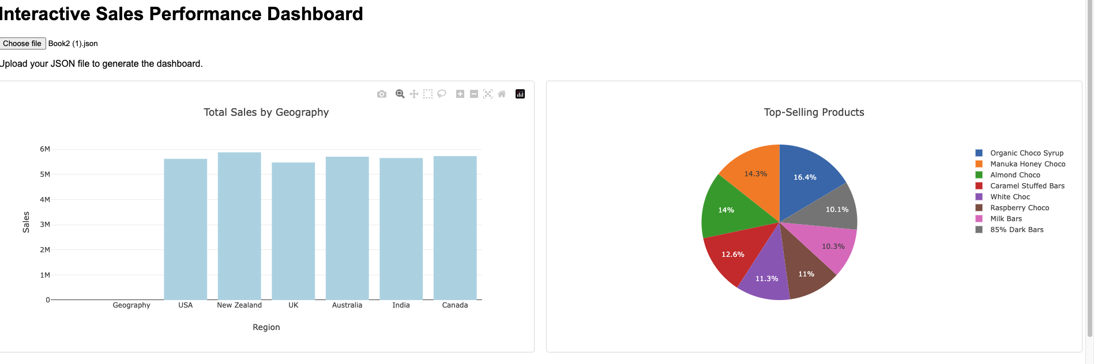

*Screenshots from the dashboard*

**Sales Insight for Stakeholders using Interactive Sales performance Dashboard.**

**Introduction** The following report provides an in-depth analysis of sales performance based on data collected from various regions, products, salespersons, and timelines of Kales Chocolate. These insights are designed to help stakeholders identify trends, recognize opportunities, and make data-driven decisions to improve sales outcomes and profitability.

**1. Total Sales by Geography**

**Key Insights:**

* The **USA**, **UK**, and **New Zealand** emerged as the top-performing regions in terms of total sales of Kales Chocolate. This indicates strong market presence and product demand in these regions.
* Regions like **India** and **Australia** displayed comparatively lower sales figures, suggesting potential markets for targeted growth initiatives.

**Recommendations:**

1. Allocate additional marketing and promotional resources to underperforming regions, such as India and Australia.
2. Conduct market research to identify barriers to entry or product adoption in these regions.
3. Strengthen distribution networks in low-performing regions to ensure product availability.

**2. Top-Selling Products**

**Key Insights:**

* **"Raspberry Choco"** and **"85% Dark Bars"** were identified as the best-performing products, driving significant revenue across multiple regions.
* Products such as **"Organic Choco Syrup"** and **"Caramel Stuffed Bars"** generated comparatively lower revenue.

**Recommendations:**

1. Maintain a strong focus on high-performing products by increasing production and inventory levels to meet demand.
2. Evaluate the performance of lower-selling products for potential improvement or strategic discontinuation.
3. Introduce targeted promotional campaigns for underperforming products to boost their market visibility.

**3. Sales Performance Over Time**

**Key Insights:**

* Seasonal trends were observed, with notable sales spikes in **March** and **November**. These periods could correspond to seasonal demand or successful marketing efforts.
* Certain months, such as **April** and **July**, experienced lower sales volumes, indicating potential areas for improvement.

**Recommendations:**

1. Align marketing campaigns and promotional offers with peak sales periods to maximize revenue.
2. Introduce loyalty programs or discounts during slower months to drive customer engagement and sales.
3. Analyse external factors (e.g., holidays, events) contributing to seasonal trends to replicate success.

**4. Sales by Salesperson**

**Key Insights:**

* **Husein Augar** and **Camilla Castle** consistently outperformed other salespersons, contributing significantly to overall sales.
* Lower-performing salespersons could benefit from additional training or performance incentives.

**Recommendations:**

1. Recognize and reward high-performing salespersons to maintain morale and motivation.
2. Provide targeted training sessions for underperforming team members to enhance their selling techniques and product knowledge.
3. Analyse sales strategies of top performers to replicate success across the team.

**5. Units Sold vs. Revenue**

**Key Insights:**

* Products such as **"White Choc"** generated high revenue despite lower unit sales, indicating premium pricing strategies.
* Conversely, products with high unit sales but low revenue may have lower profit margins or were sold at discounted rates.

**Recommendations:**

1. Reassess pricing strategies for high-performing products to ensure competitiveness while maintaining profitability.
2. Explore opportunities to increase margins on high-volume, low-revenue products through cost optimization or price adjustments.
3. Introduce bundle offers to promote complementary product sales and increase average transaction value.

**Overall Recommendations for Stakeholders**

1. **Optimize Regional Focus:** Allocate resources to high-performing regions while developing strategies for market entry or growth in underperforming areas.
2. **Enhance Product Portfolio:** Focus on high-demand products, discontinue low-performing ones, and innovate new offerings based on market trends.
3. **Leverage Sales Trends:** Utilize historical sales data to forecast future demand and align production schedules and marketing strategies accordingly.
4. **Empower Sales Teams:** Invest in employee development, recognize top performers, and provide tools and training to boost overall team performance.
5. **Data-Driven Decision Making:** Regularly update dashboards and reports to monitor performance and adapt strategies based on real-time insights.

**Conclusion** This report highlights key areas of success and improvement across geographies, products, timelines, and sales teams. By implementing the outlined recommendations, stakeholders can capitalize on existing opportunities, address challenges, and drive sustainable growth for the organization.